Milestone 02-Android

Professor: Charles Hoot

Team: Pappu Sah, Jing li, Abhishek Manandhar, Aadit Yadav

Name of the Application: Panic

This application is used in security purpose. User can connect to nearest hospital, police station and fire station. Just by pressing the panic button, user’s current location can be send to Family members at regular interval SMS and automatically dial 911.

Layouts and their Description:

User Registration: Basic Details of the user with details of 3 Family Members details such as Name & Phone No. Direct Login and details will be saved.

Panic Button: Gets activated by pressing home button n times or shouting "Panic", after which the app sends Panic SMS to members and dials 911 automatically, and a loud Alarm will be triggered and at regular intervals SMS of current location.

Edit Member Details: User can edit member details.

Hospital: View nearest Hospital with the use of Google Place API and display on a map with directions and with contact details.

Police Station: View nearest Hospital with the use of Google Place API and display on a map with directions and with contact details.

Fire Station: View nearest Fire Station with the use of Google Place API and display on a map with directions and with contact details.

Front End: Android

Back End: Java, mysql, Asp.net with c#, firebase

Risk Components: We are working with multiple APIs. Mostly consisting of Google Login Authorization and Google Map API. Likewise, we might use some more API which we are current doing research on.

Require functionality:

1)Map, Database for user login and storing the user information,

2) Descriptions of data to be entered into the system

3)Descriptions of operations performed by each screen

4)Security requirements

* Admin need to login with their valid login credentials in order to access the system
* View User: All the registered user’s details can be viewed by admin.

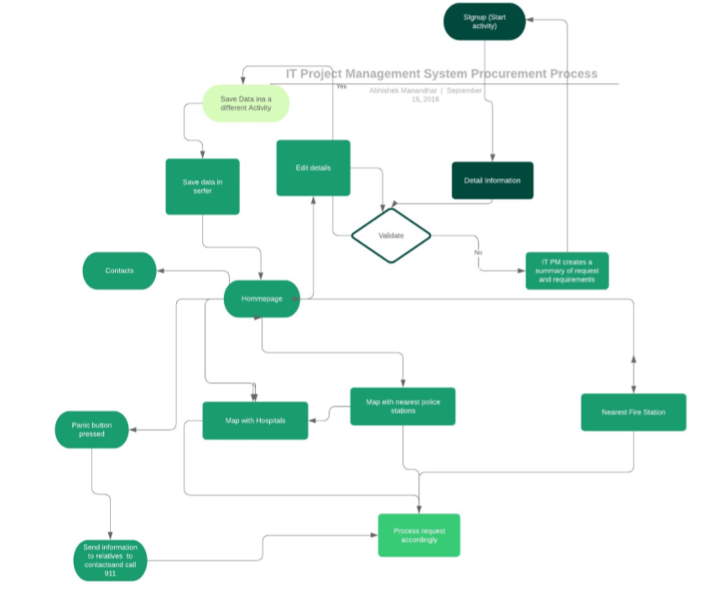

Division of work:

Aadit: Aadit is the project manager he is looking into both front end and the back-end and currently he is currently working in firebase Authentication.

Abhishek: Is working on google Map integration and GPS system in general for the Application> he is mostly working in the back end.

Jing Li: Is mostly working on front end of the application and he is also helping Pappu with the research.

Pappu Sah: Is researching information on various resources we can use in this application to make it more productive

Some of the test performed:

|  |  |
| --- | --- |
| Login user Authentication | Pass |
| Registration for new User | Pass |
| Storing data in Firebase | Pass |
| Sign out User | pass |
| Change Password | Fail |
| Google Map Integration | Fail |
| Current Location | Fail |
| GPS notification | Fail |
| General App Navigation | Pass |

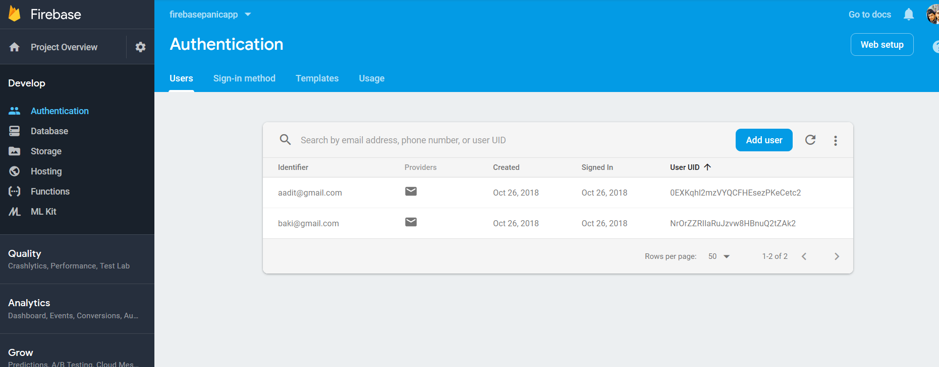Small run test of Login Authentication:

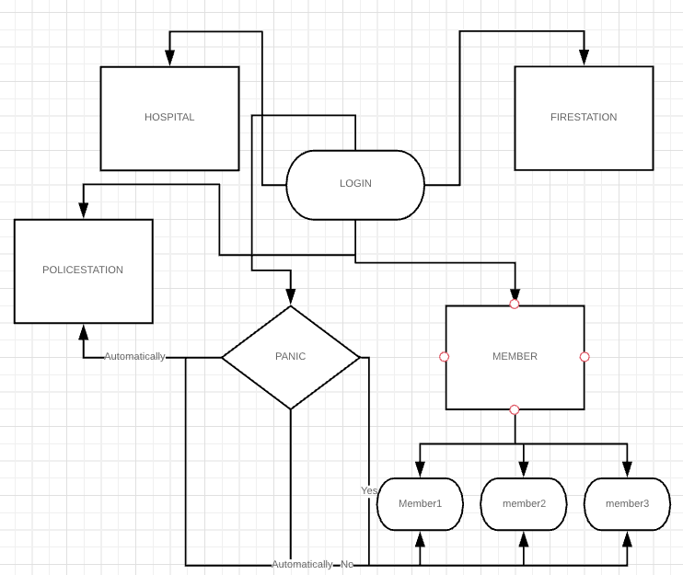

Currently working ER_Diagram